**Azad Kashmir:**

Banjosa Lake

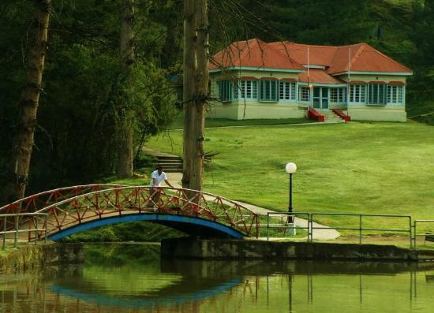

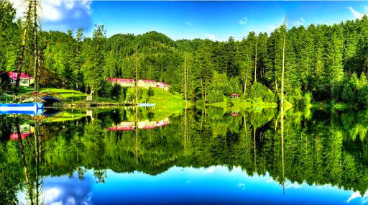

**Banjosa Lake** is an artificial lake and a tourist resort 18 kilometers (11mi) from the city of Rawalakot in Poonch District of Azad Kashmir, Pakistan. It is located at an altitude of 1,981 meters (6,499ft).

Neelum Valley

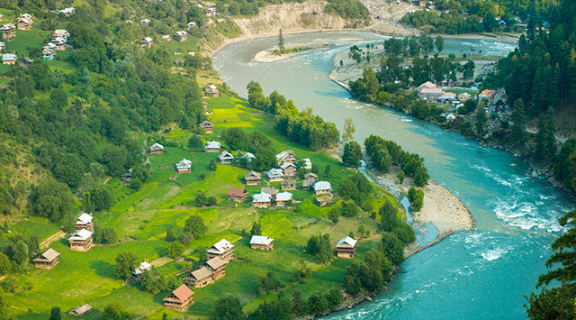

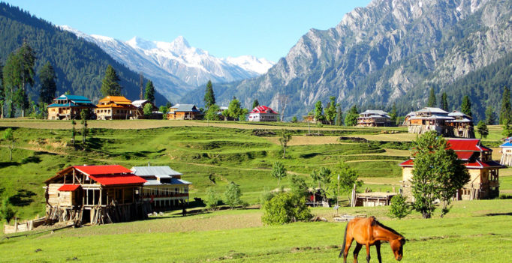

**Neelum District** (also spelt as **Neelam**; is the northernmost district of Azad Kashmir, Pakistan. Taking up the larger part of the **Neelam Valley**, the district has a population of 191,000 (as of 2017). It was badly affected by the 2005 Kashmir earthquake.

Toli Pir

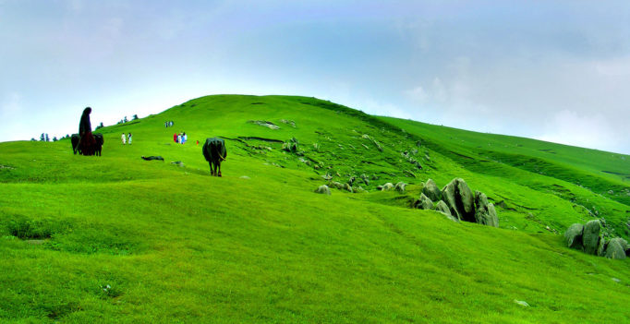

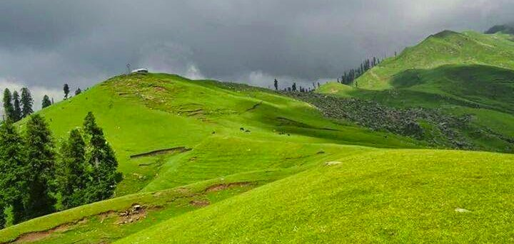

**Tolipir**‎ also spelled Tolipeer, Tauli Pir, Tooli Pir, Toli Pir, or Toli Peer) is a hilltop area situated in Tehsil Rawalakot in the Poonch District of Azad Kashmir. Its approximate elevation is about 8800ft above sea level. It is about 30km, or a 120-minute drive, from Rawalakot in Azad Kashmir. Abbaspur, Bagh and Poonch River can be viewed from Toli Pir.

Leepa Valley

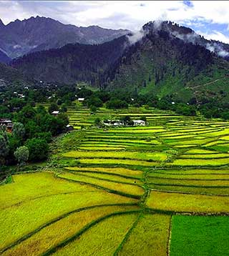

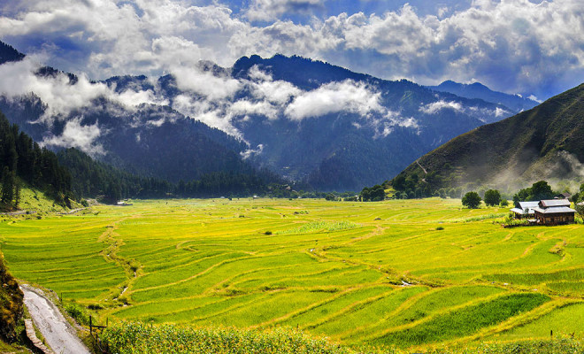

**Leepa Valley** is located in Azad Kashmir, 105 kilometres (65mi) from Muzaffarabad. The valley is divided into the Reshian, Dao Khan, Leepa, and Chananian sections. Leepa Valley was formerly part of Karnah tehsil of Kupwara district in Jammu and Kashmir, India. The valley is now part of Jhelum Valley District in Azad Kashmir, Pakistan. It has been an area of strife among the two neighboring countries.

Red Fort

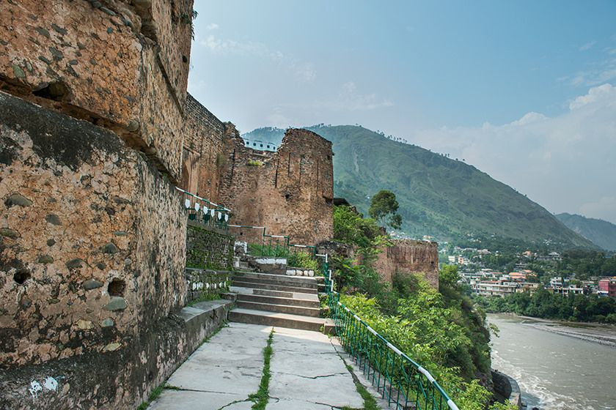

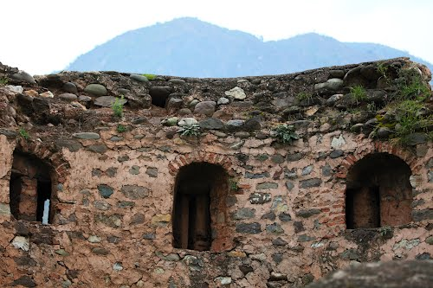

**Red Fort** - also known as the **Muzaffarabad Fort** was built by the Chak rulers of Kashmir in the 16th century. The current locality is called Center Plate. Locally, it is known as the "Rutta Qila" or just "qila".

Pir Chinasi

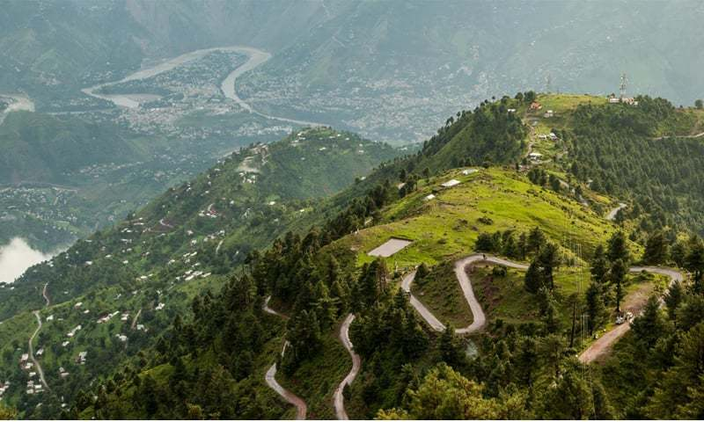

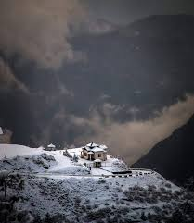

**Pir Chinasi** is a shrine and tourist destination located 30 kilometers (19mi) east of Muzaffarabad city on the top of hills at an elevation of 2,900 metres (9,500ft). The mountain peak has gained large fame for its ziyarat of a famous Saint Pir Chinasi Known as Pir Sayed Hussain shah Bukhari.